Availability Changes
To change your availability log in to your teamworx account at zaxbys.ct-teamworx.com
Once you are logged in go to My Time > Availability > Add time.
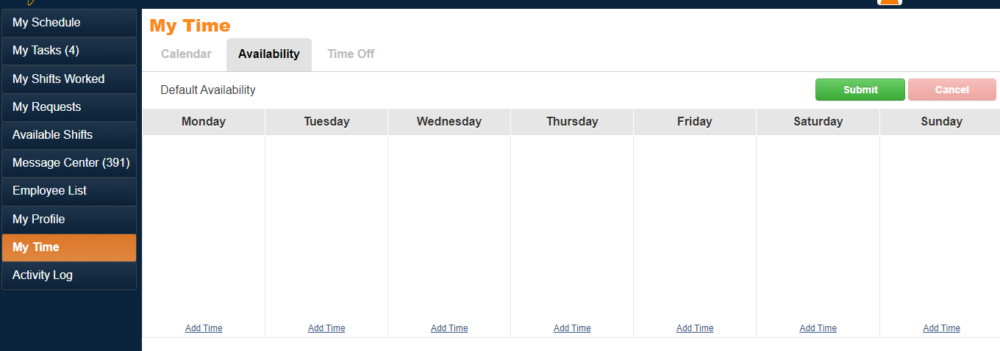

After selecting “Add Time”for the corect day,
make sure that the Not Available tab is
highlighted (We can not see perferred or available
when scheduling so please refrain for using those tabs)
put in the time that you ARE NOT available to
work or check the box next to All Day and select Add.

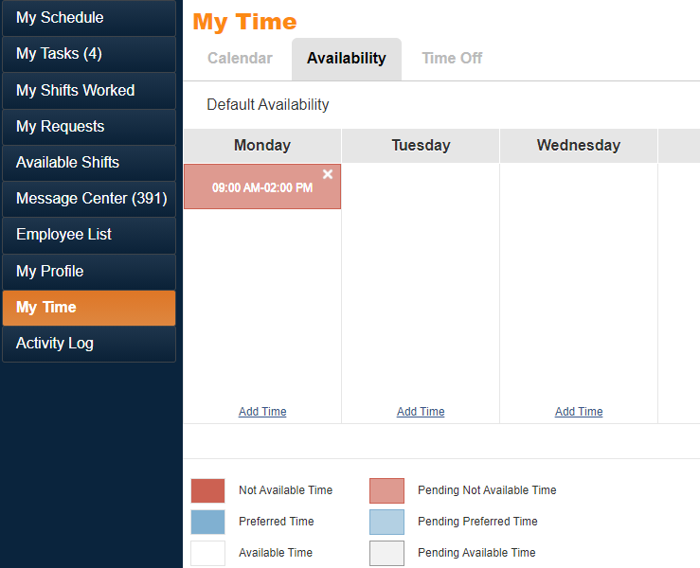
Once you have added the time that you are NOT available for the correct days you should see the time highlighted in red under the correct days
If you would like to open your availability just hit the “X” at the top right of the red highlighted section and select submit. The box below will appear, select the week date that you would like the availability to start.
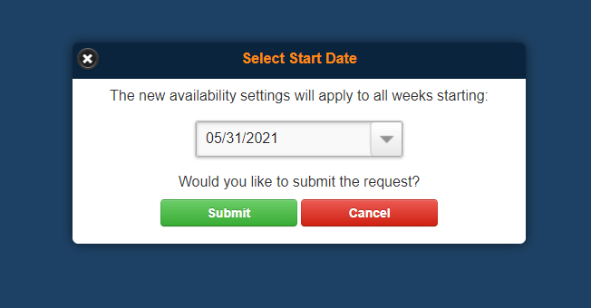

Time off Request
To change your availability plase log in to your teamworx account > zaxbys.ct-teamworx.com
Once you are logged in go to My Time > Time Off. Select the day/dates that you would like to request off and either input the time that you need off or check the box next to All Day. You can put in the reason that you would like off in the message field but this is optional and submit.
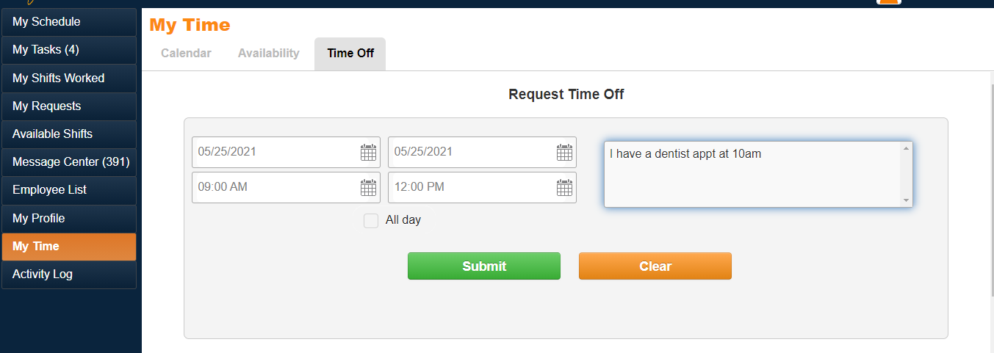

After selecting submit you should see a box appear letting you know that your time off request was created. The next step is for you to wait on an approval from your General Manager.
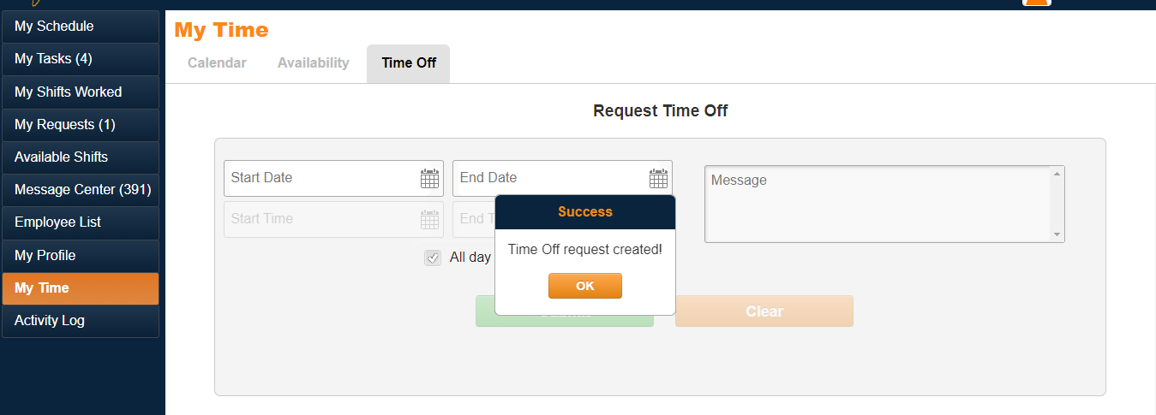
Remember: Schedule request must be in on Mondays by 5pm for the following week.

